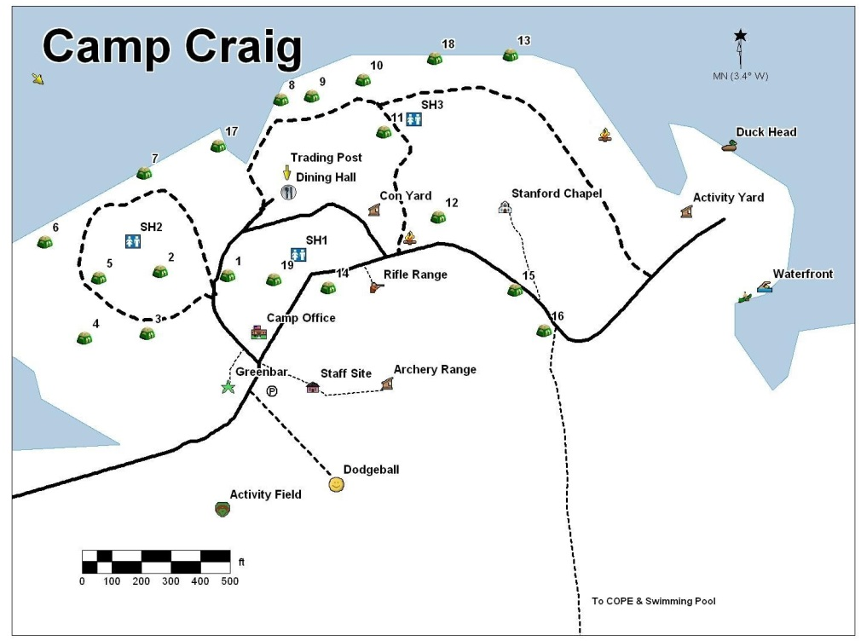
Troop 93/Troop22/Pack 144 Campout
October 25–27, 2019

Boxwell Scout Reservation (We will camp in the Camp Craig Activity Field)
1260 Creighton Lane
Lebanon, TN 37087
Phone: 615-945-1479

This is always a great trip to have full interaction between Troop 93, Troop 22, and Pack 144 for all scouts, adults, and siblings. We will have lots of activities such as Tomahawk Throw, Archery, Gaga Ball, Kickball, Day Hike, Campfire, and fellowship. We will have a demonstration area to help teach parents about camping, cooking, knot tying, First Aid, etc..

Friday, October 25th – Weather ° High ° Low TBD
If you come out Friday night, here is the average temperature is 77°F to 67°F, rarely falling below 54°F or exceeding 86°F. Please arrive after 5:30 PM and camp in assigned areas off the Power Point. Mr. Matthew Smith, 615-969-0662, Scoutmaster of Troop 93 will direct you if you don’t.

Departure:
Saturday, October 26th – Weather ° High ° Low TBD
Plan to be at the campsite location between 10:00
- We will not meet at the church. Drive to Camp Craig. The drive to the campground is about 45 minutes.
Meals:
- Grubmasters will be cooking for the entire troop for the weekend.
- Grubmasters will serve Saturday lunch, dinner and Sunday breakfast.

Adult Meals for the weekend
Saturday Breakfast (if you plan to come out Friday night) – French Toast, Sausage, Milk, Juice (Coffee on your own)
Saturday Lunch – Cheeseburgers, Chips, Apples
Saturday Dinner – Boston Butt and Smoked Turkey, Salad, Dessert
Sunday Breakfast – Cheesy Eggs, Bacon, Milk, Juice (Coffee on your own)

Activities: The Patrols will be assigned to work at different stations to help supervise the rotation for Troop 22 and Pack 144. They will help them with advancement and learn skills to increase their interest in Scouts BSA. Maximum participation is necessary for us to be successful. Here are the assignments: TBD

Saturday Schedule
10:00: Arrive at Camp Craig, set up camp, rehearse stations and rotation
12:00: Lunch
1:00 – 4:00 PM: The ranges will be open. We will also have the patrols teach the following.

Archery
Tomahawk Throw
Mystery Event
Gaga Ball
Kickball

5:30 to 8:00 PM: Dinner prep/Dinner/work on skits for Campfire
8:00 PM: Campfire/Skits
9:30 PM: Lights out

Sunday Schedule
8:00 AM: Breakfast
9:00 AM Chapel
9:15 AM: Breakdown Campsite
10:00 AM: Depart

Gear:
- Attire: Scouts need to wear their Class B shirts
- This is car camping, so plan your camping gear accordingly. We will be camping in the field by patrol.
- Bring a water bottle and sunscreen. Not sure what the weather report will be. The weather report will be updated as we get closer. Be Prepared!

Cost:
- The Scoutmaster/Grubmaster will let you know what you owe.

Return:
Sunday, October 27th – Weather ° High ° Low TBD
We will depart the campsite after breakfast Sunday morning. Please plan to pick up your son by 10:00 AM unless you have prearranged a ride.

Trip Leader & Driver Cell Phones (to be listed once participants are confirmed):

Matthew Smith: (615) 969-0662

